Assignment 9 : Docker
One Git repo
Three branches:
- main (or master)
- 2026Q1
- 2026Q2
Jenkins Master (JM)
3 Jenkins Slaves
Each slave has Docker installed Using bind mount
Deploy: slave1 -- M, Q1, Q2 slave2 -- M, Q1, Q2 slave3 -- M, Q1, Q2
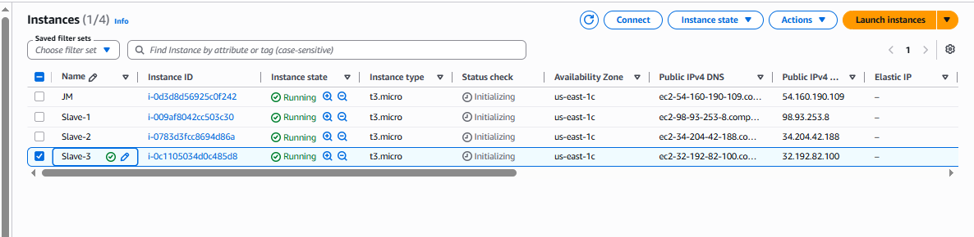

Install java in all machine :
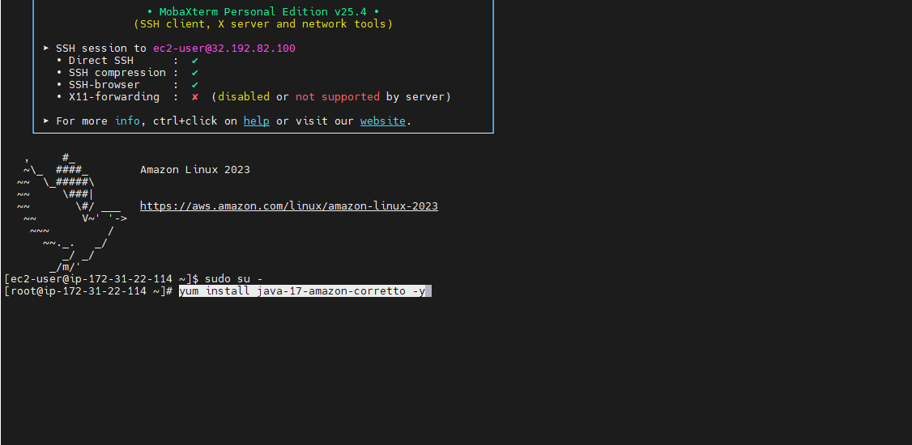

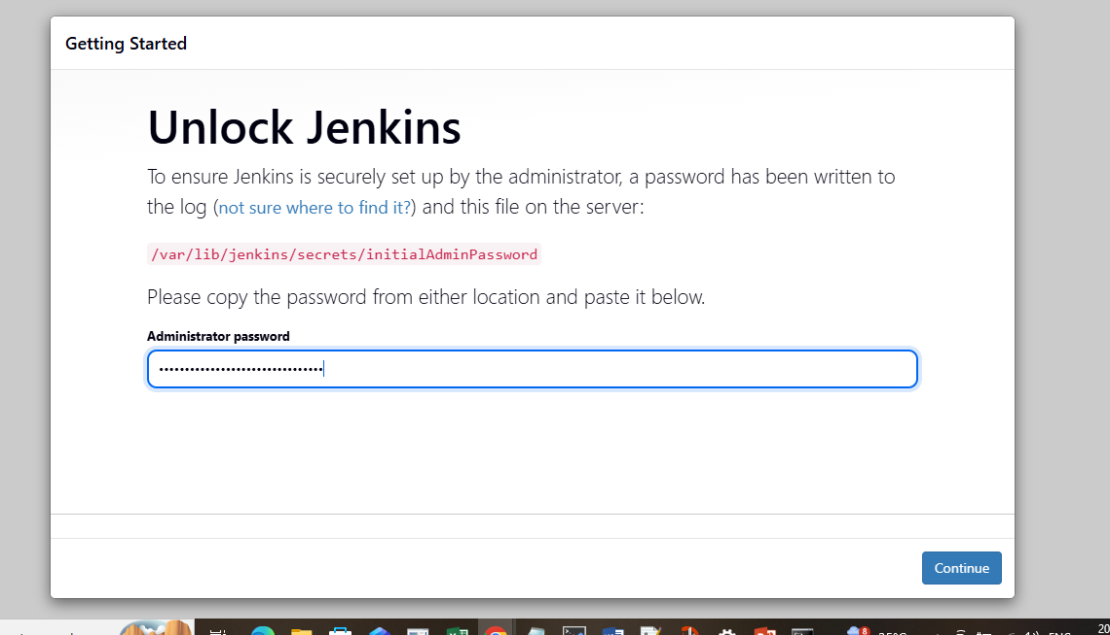

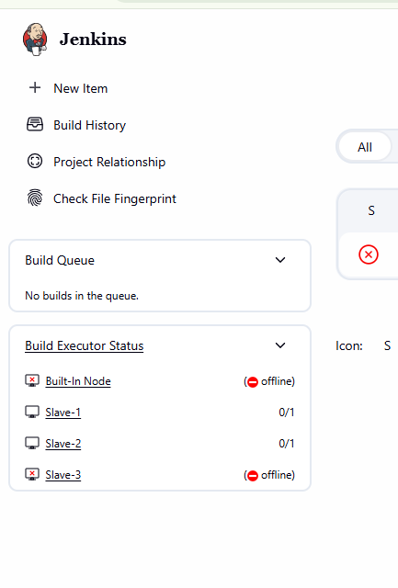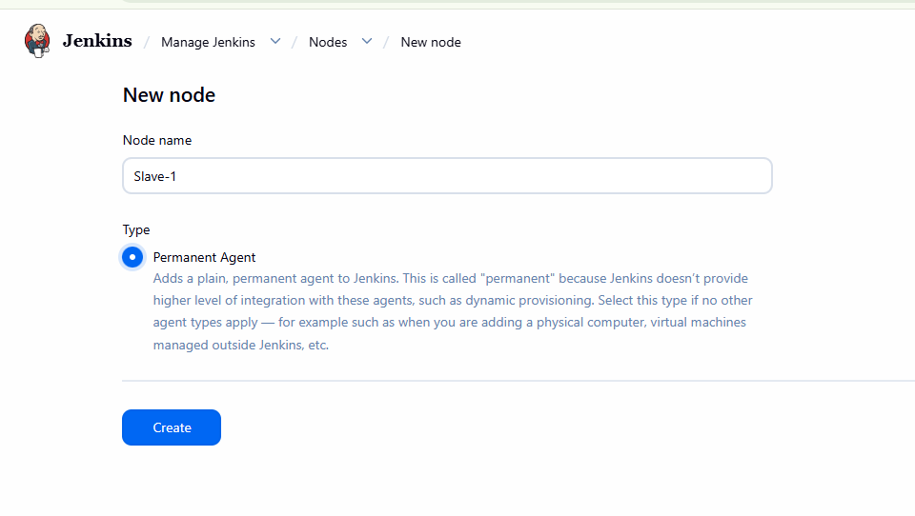

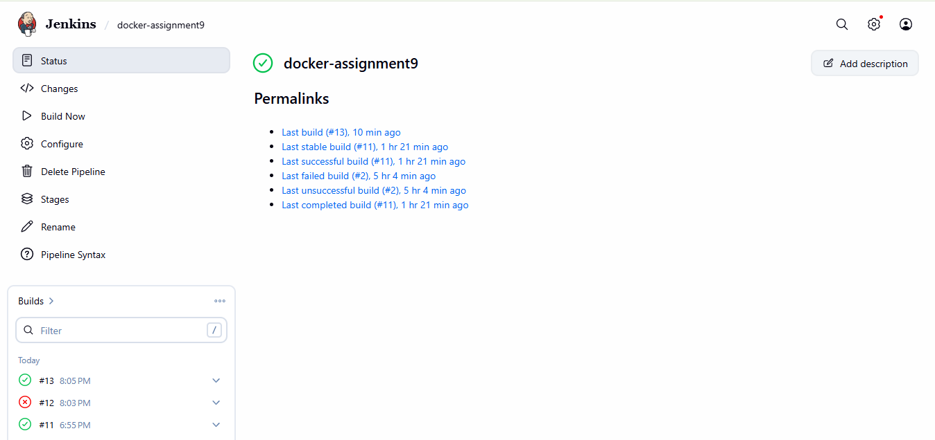

Slave 1 :
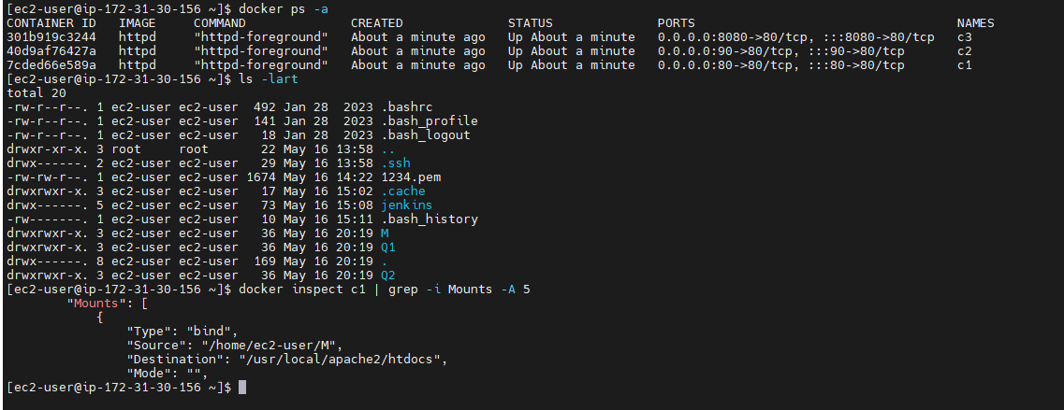
http://98.93.253.8:80
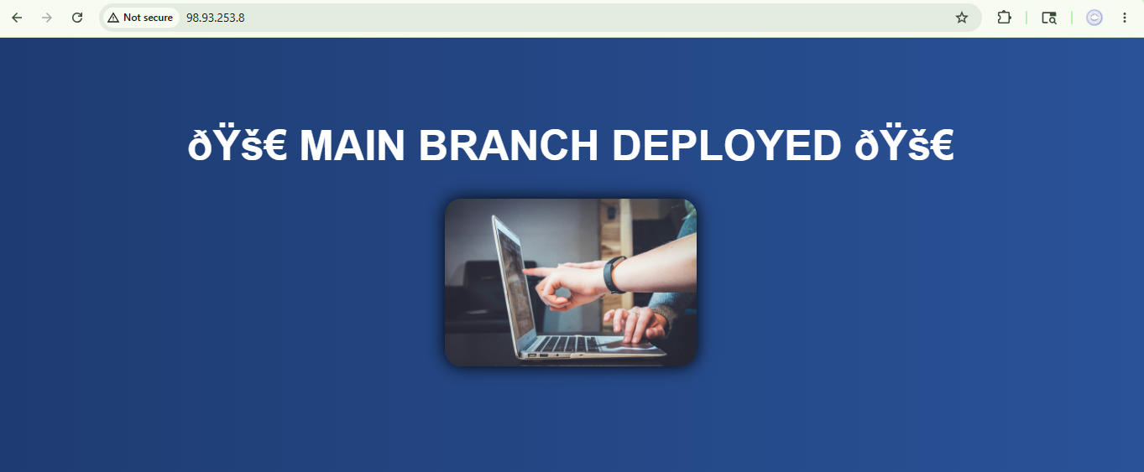
http://98.93.253.8:90
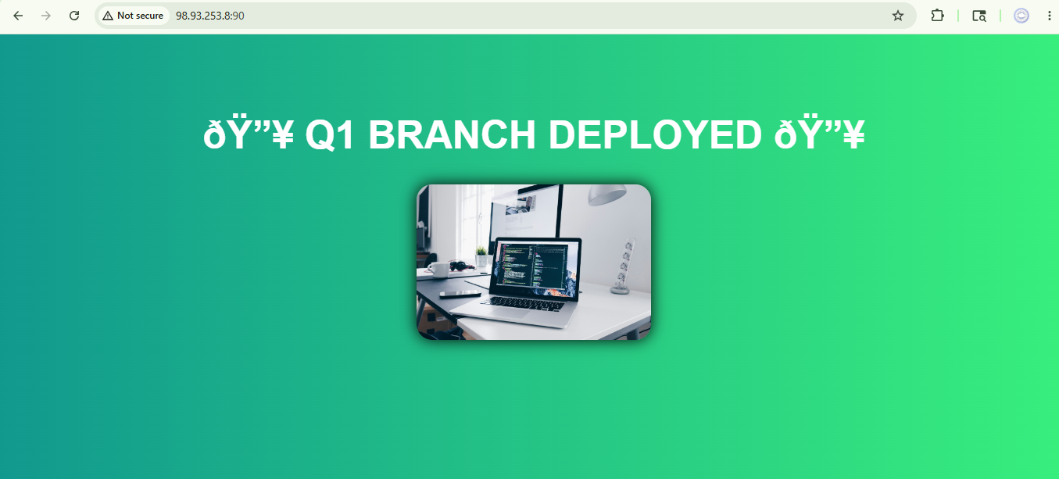
http://98.93.253.8:8080/

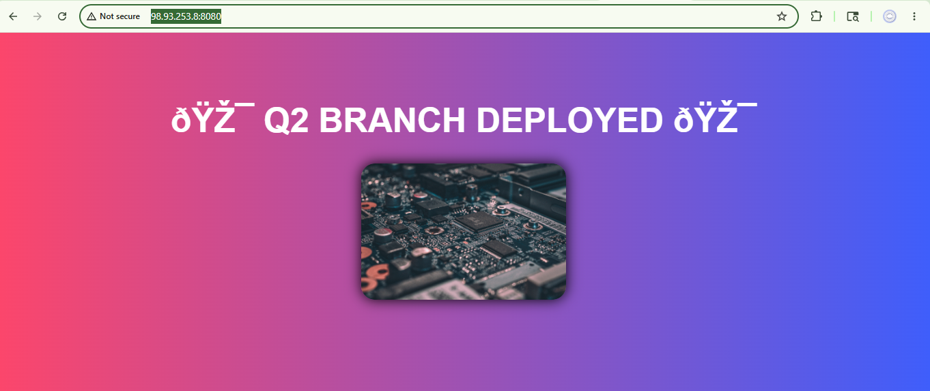

Slave 2 :
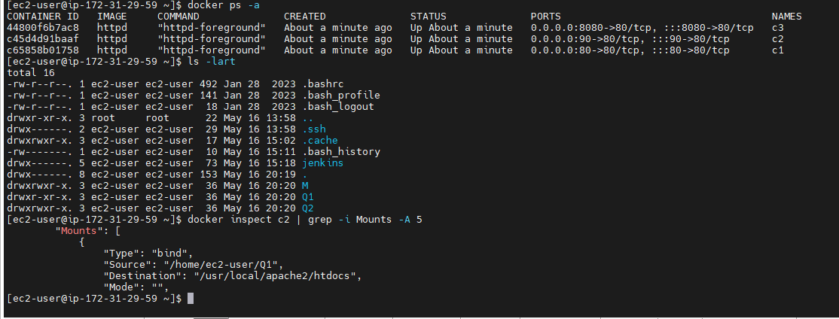

http://34.204.42.188:80

http://34.204.42.188:90
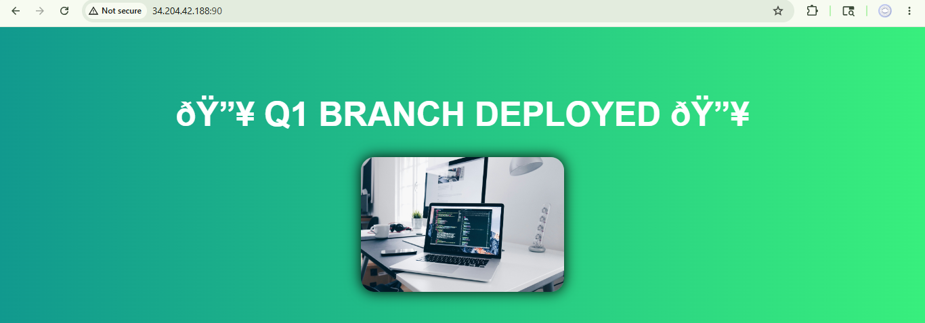
Slave3 :

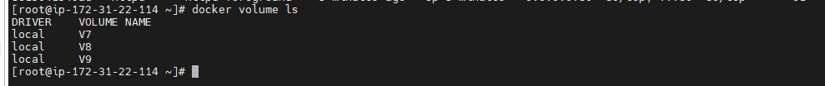
Check index file in container if present
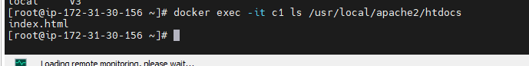
http://34.204.42.188:8080

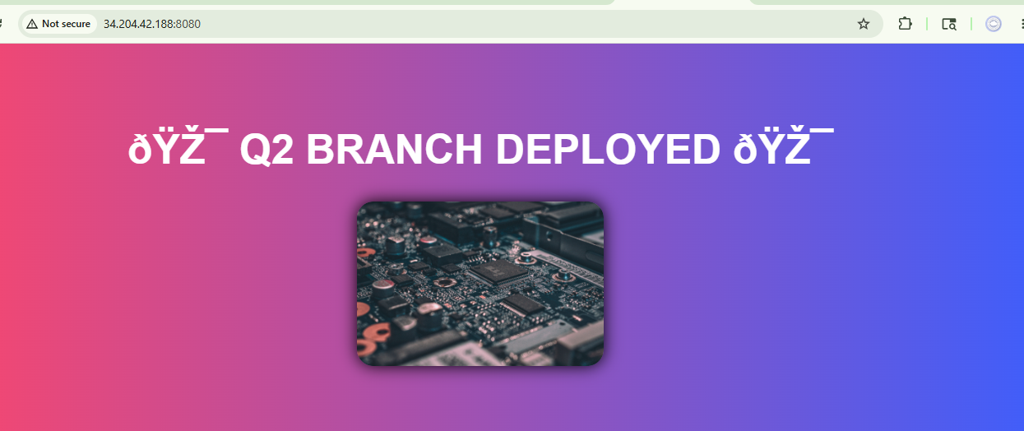

Script :
pipeline {

agent none

stages {

// ================= SLAVE 1 =================

stage('Deploy All on Slave1') {

agent { label 'Slave-1' }

steps {

sh '''

# MAIN
rm -rf repo
git clone -b main https://github.com/Pallavi-250598/Repo-1.git repo

rm -rf /home/ec2-user/M
mkdir -p /home/ec2-user/M

docker rm -f c1 || true

docker run -dit --name c1 -p 80:80 -v /home/ec2-user/M:/usr/local/apache2/htdocs httpd

cp -r repo/. /home/ec2-user/M/

# Q1
rm -rf repo
git clone -b 2026Q1 https://github.com/Pallavi-250598/Repo-1.git repo

rm -rf /home/ec2-user/Q1
mkdir -p /home/ec2-user/Q1

docker rm -f c2 || true

docker run -dit --name c2 -p 90:80 -v /home/ec2-user/Q1:/usr/local/apache2/htdocs httpd

cp -r repo/. /home/ec2-user/Q1/

# Q2
rm -rf repo
git clone -b 2026Q2 https://github.com/Pallavi-250598/Repo-1.git repo

rm -rf /home/ec2-user/Q2
mkdir -p /home/ec2-user/Q2

docker rm -f c3 || true

docker run -dit --name c3 -p 8080:80 -v /home/ec2-user/Q2:/usr/local/apache2/htdocs httpd

cp -r repo/. /home/ec2-user/Q2/

'''
}
}

// ================= SLAVE 2 =================

stage('Deploy All on Slave2') {

agent { label 'Slave-2' }

steps {

sh '''

# MAIN
rm -rf repo
git clone -b main https://github.com/Pallavi-250598/Repo-1.git repo

mkdir -p /home/ec2-user/M

docker rm -f c1 || true

docker run -dit --name c1 -p 80:80 -v /home/ec2-user/M:/usr/local/apache2/htdocs httpd

cp -r repo/. /home/ec2-user/M/

# Q1
rm -rf repo
git clone -b 2026Q1 https://github.com/Pallavi-250598/Repo-1.git repo

mkdir -p /home/ec2-user/Q1

docker rm -f c2 || true

docker run -dit --name c2 -p 90:80 -v /home/ec2-user/Q1:/usr/local/apache2/htdocs httpd

cp -r repo/. /home/ec2-user/Q1/

# Q2
rm -rf repo
git clone -b 2026Q2 https://github.com/Pallavi-250598/Repo-1.git repo

mkdir -p /home/ec2-user/Q2

docker rm -f c3 || true

docker run -dit --name c3 -p 8080:80 -v /home/ec2-user/Q2:/usr/local/apache2/htdocs httpd

cp -r repo/. /home/ec2-user/Q2/

'''
}
}

// ================= SLAVE 3 =================

stage('Deploy All on Slave3') {

agent { label 'Slave-3' }

steps {

sh '''

# MAIN
rm -rf repo
git clone -b main https://github.com/Pallavi-250598/Repo-1.git repo

mkdir -p /home/ec2-user/M

docker rm -f c1 || true

docker run -dit --name c1 -p 80:80 -v /home/ec2-user/M:/usr/local/apache2/htdocs httpd

cp -r repo/. /home/ec2-user/M/

# Q1
rm -rf repo
git clone -b 2026Q1 https://github.com/Pallavi-250598/Repo-1.git repo

mkdir -p /home/ec2-user/Q1

docker rm -f c2 || true

docker run -dit --name c2 -p 90:80 -v /home/ec2-user/Q1:/usr/local/apache2/htdocs httpd

cp -r repo/. /home/ec2-user/Q1/

# Q2
rm -rf repo
git clone -b 2026Q2 https://github.com/Pallavi-250598/Repo-1.git repo

mkdir -p /home/ec2-user/Q2

docker rm -f c3 || true

docker run -dit --name c3 -p 8080:80 -v /home/ec2-user/Q2:/usr/local/apache2/htdocs httpd

cp -r repo/. /home/ec2-user/Q2/

'''
}
}

}
}

